DATA STRUCTURE AND ALGORITHMS

Roll no: 25BAD014
Name: Ashvitha I
Class:A-10 Slot
Course Code: 25CSI024

TASK-01
Implementation of a List using Array ADT
Aim:
To implement the basic list operations such as Insertion, Deletion, Updation, and Display using Array ADT in C.

Pseudocode:
START
Create a structure Array
Read the size of the array
Read the array elements
Display the menu
1. Insertion
2. Deletion
3. Updation
4. Display
Read user's choice
IF choice = 1 THEN
Read position and value
Shift elements to the right
Insert the value
Increase size
ELSE IF choice = 2 THEN
Read position
Shift elements to the left
Decrease size
ELSE IF choice = 3 THEN
Read position and new value
Replace the element
ELSE IF choice = 4 THEN
Display all array elements
ELSE
Display "Invalid Choice
STOP

Sourse Code:
S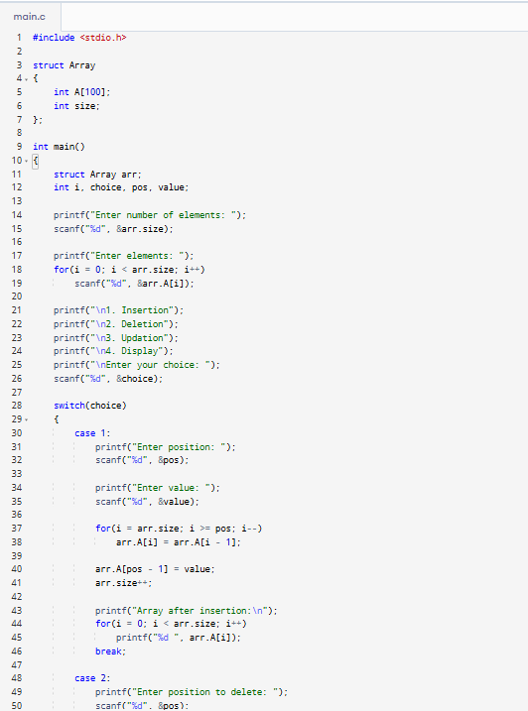
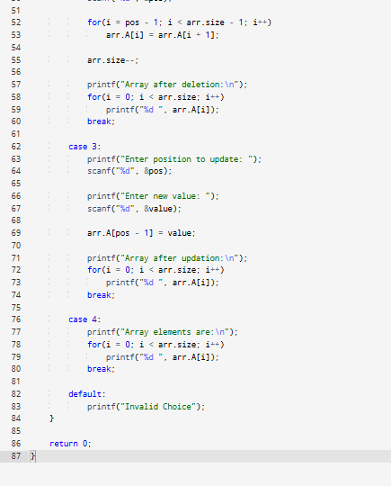

Output:
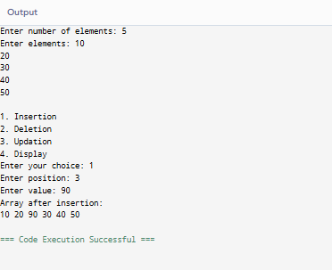

Output:
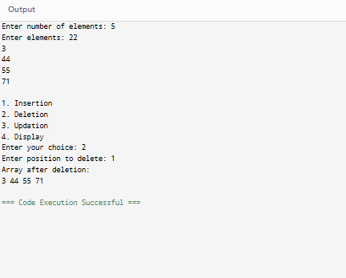

Output:
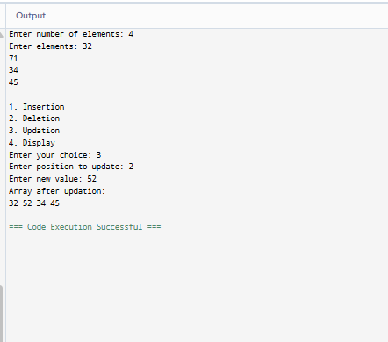

TASK-02
Linear Search using Array ADT
Aim:
To implement the Linear Search operation on a List using Array ADT in C.

Pseudocode:

START
Create structure Array
Read size of the array
FOR i = 0 to size - 1
Read A[i]
END FOR
Read key
FOR i = 0 to size - 1
IF A[i] == key THEN
Display "Element Found at index", i
STOP
END IF
END FOR

Display "Element Not Found"
STOP

Sourse Code:
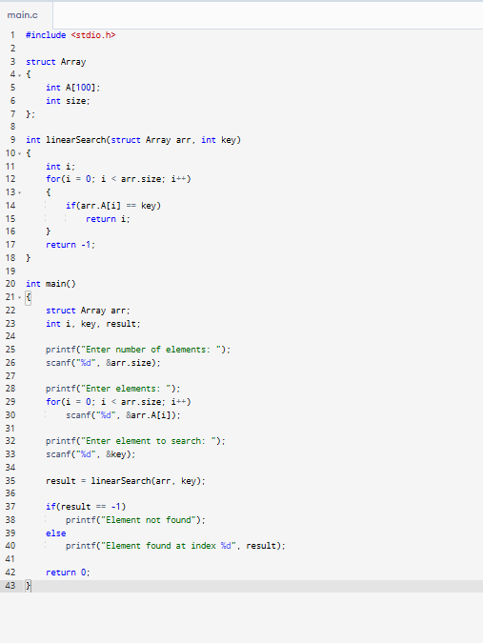
Output:
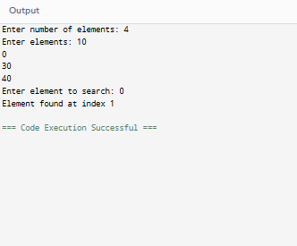

TASK-03
Binary Search using Array ADT
Aim:
To implement the Binary Search operation on a sorted List using Array ADT in C using a structure.

Pseudocode:
START
Create structure Array
Read size of the array
FOR i = 0 to size - 1
Read A[i]
END FOR
Read key
Set low = 0
Set high = size - 1
WHILE low <= high
mid = (low + high) / 2
IF A[mid] == key THEN
Display "Element Found at index", mid
STOP
ELSE IF A[mid] < key THEN
low = mid + 1
ELSE
high = mid - 1
END IF
END WHILE
Display "Element Not Found"
STOP

Sourse Code:
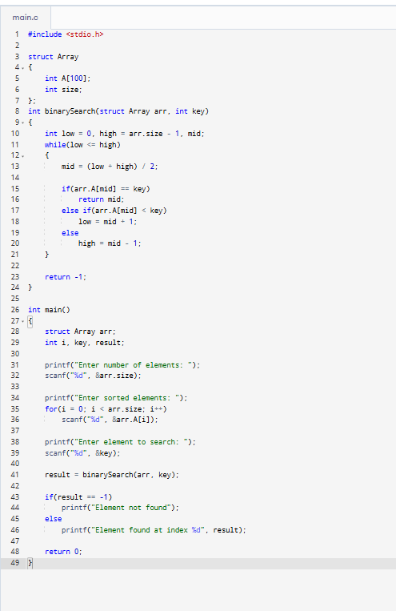

Output:
